Tool used: draw.io

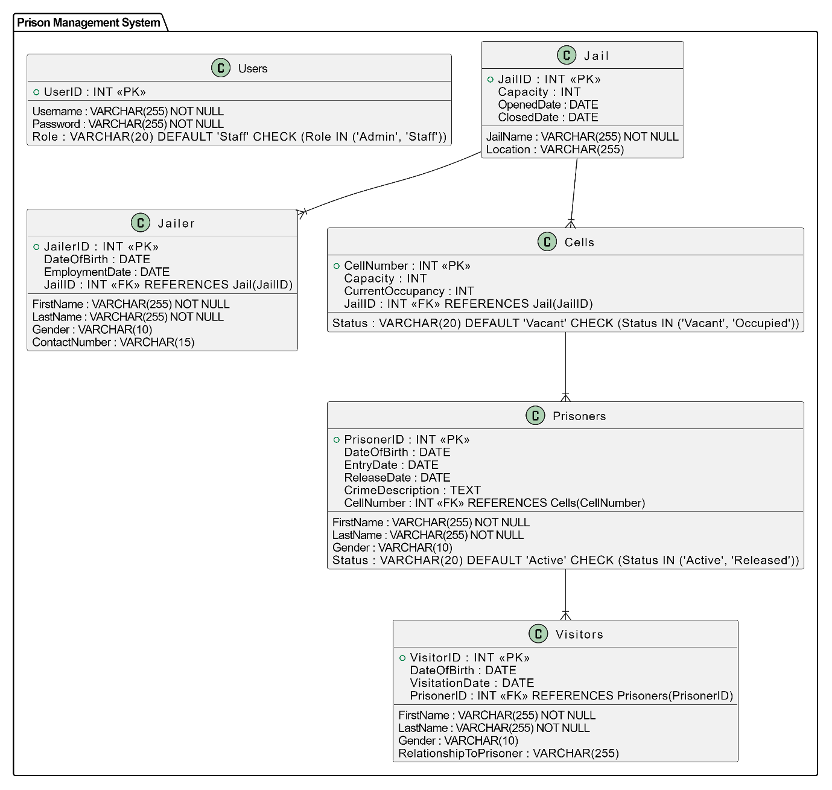

Creating Tables

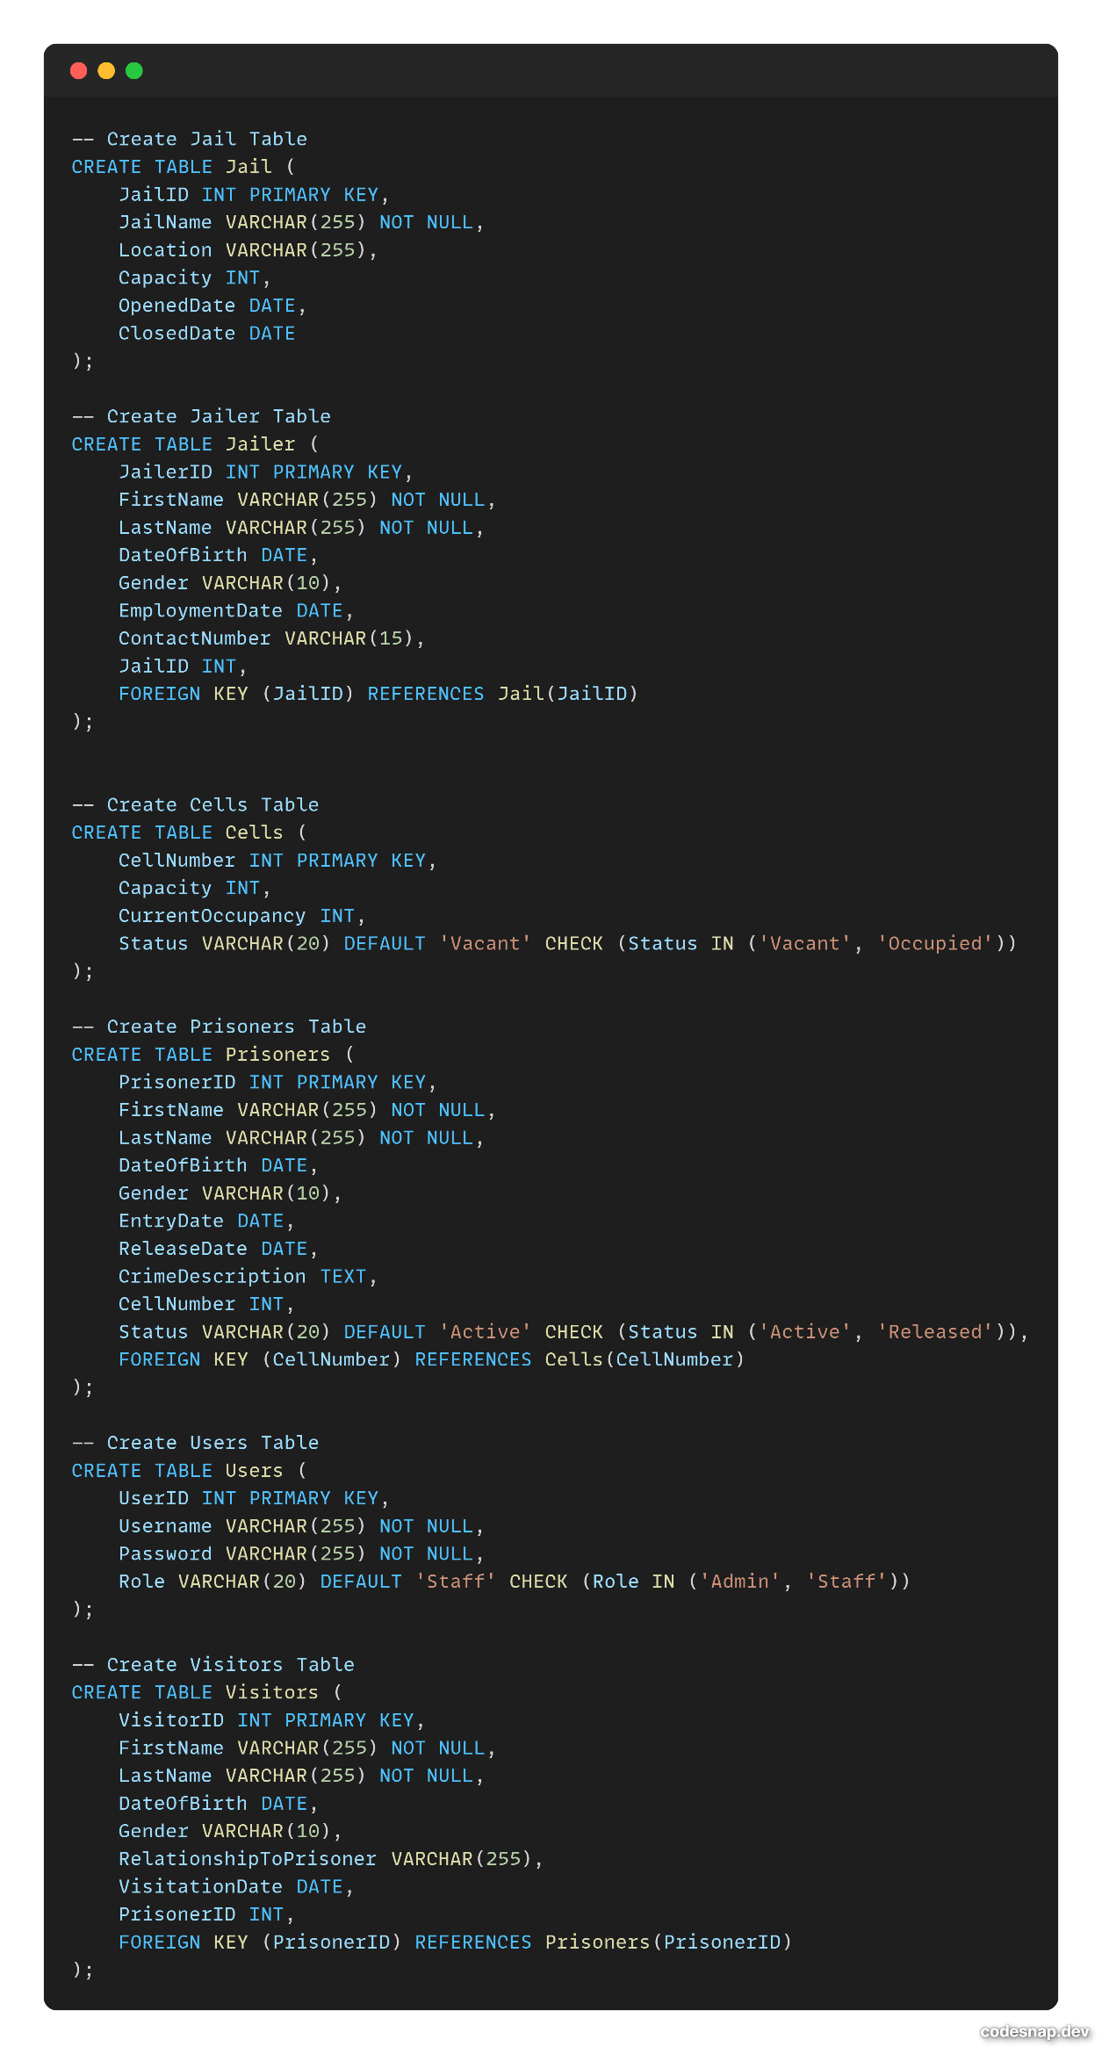

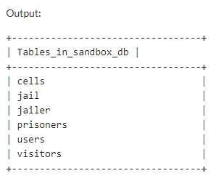

Implementing relationships and Foreign keys

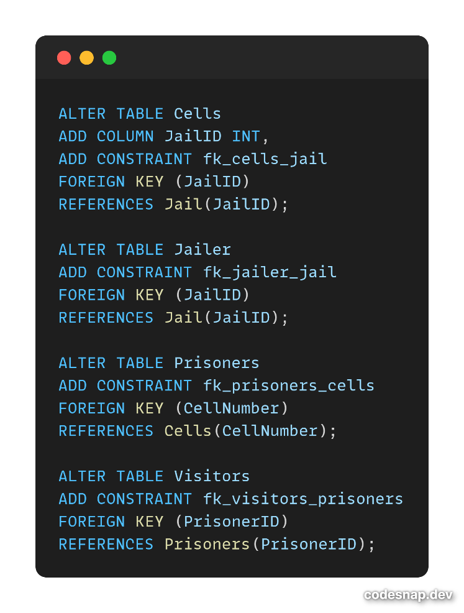

Query to add new prisoners.

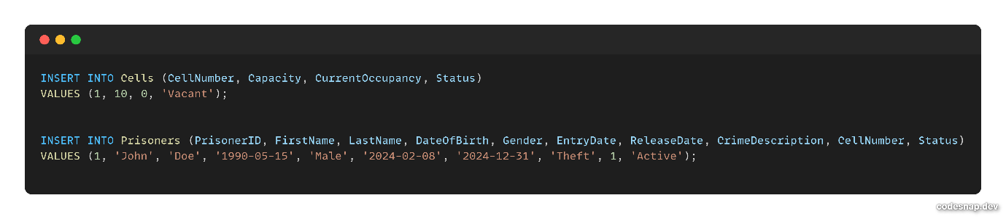



Query to show all convicts with their Crime tagged with entry date

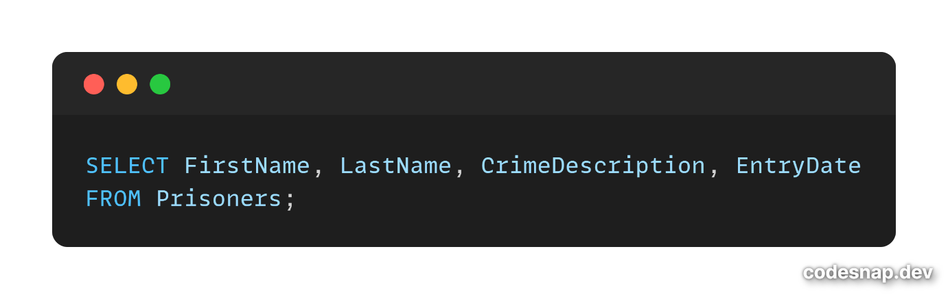 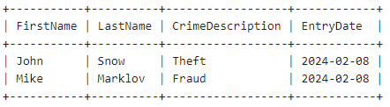

Query to calculate days the Prisoners have been in the Cell.

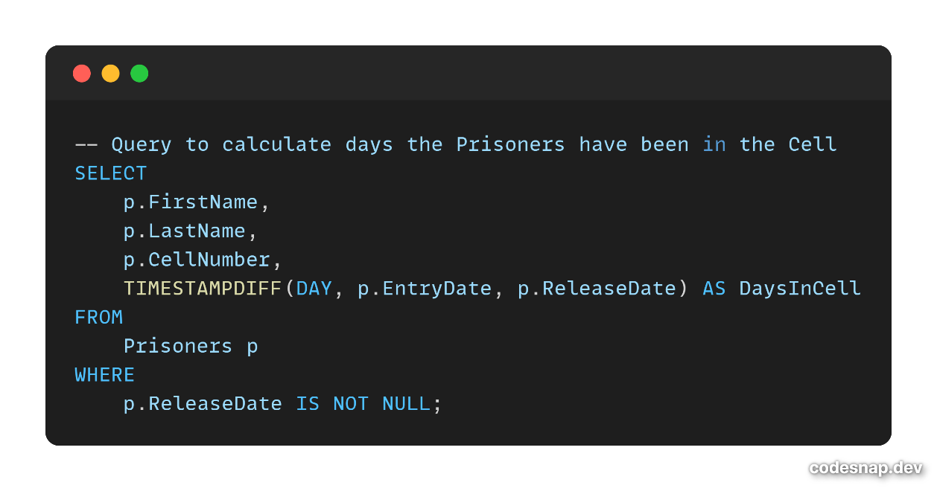

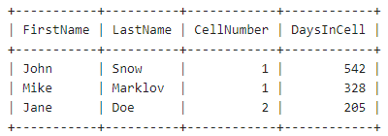

Query to fetch and show data from various related tables.

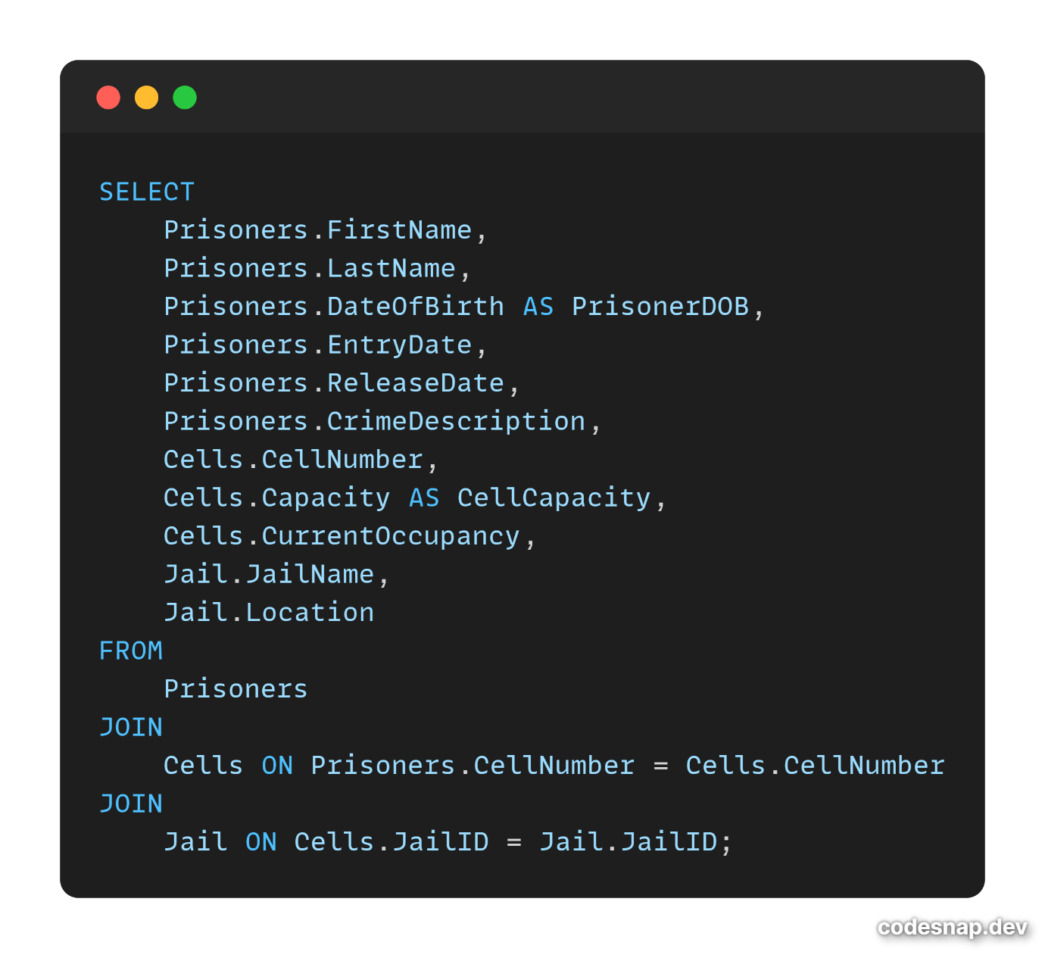

Optimize repeated read operations using views/materialized views.